**Project Design Phase-II**

**Technology Architecture**

|  |  |
| --- | --- |
| Date | 25 October 2022 |
| Team ID | PNT2022TMID28768 |
| Project Name | Visualizing and Predicting Heart Diseases with an Interactive Dashboard |

**Technology Architecture:**

The Deliverable shall include the architectural diagram as below and the information as per the table1 & table 2

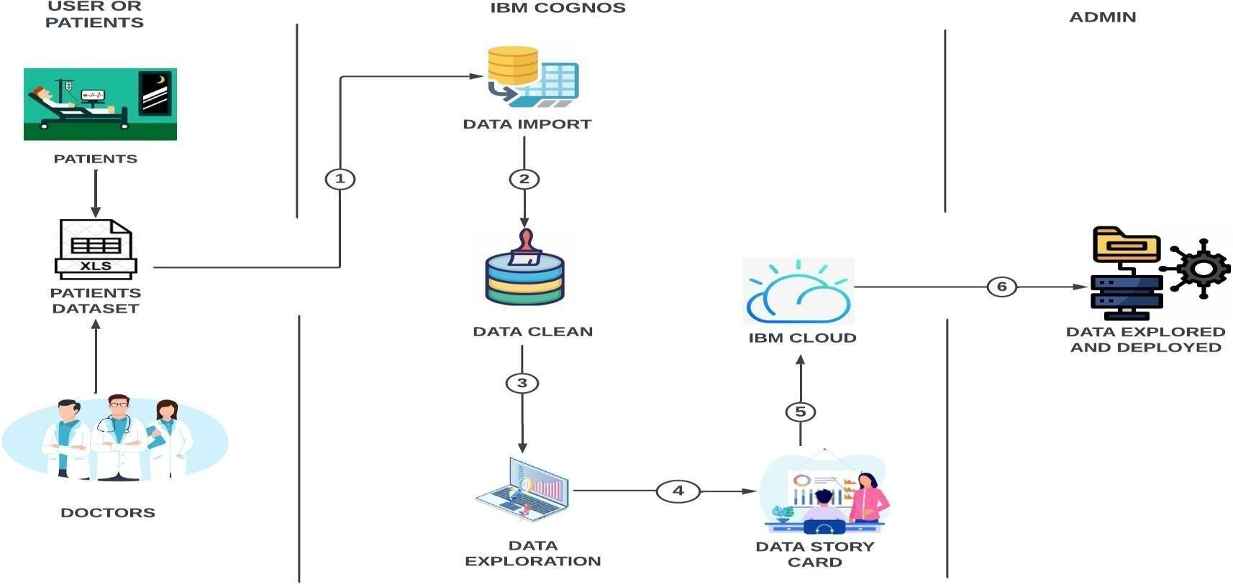

**Table-1: Components & Technologies:**

|  |  |  |  |
| --- | --- | --- | --- |
| **S.No** | **Component** | **Description** | **Technology** |
| 1. | User Interface | How user interacts with application e.g., Web UI, Mobile App, Chatbot etc. | IBM Cognos / Python. |
| 2. | Data Set | The data set prepared for hospitals health care | Python. |
| 3. | IBM Cognos | Data analytics platform | IBM Watson service |
| 4. | Data Import | Data set is imported in IBM Cognos | IBM Watson Assistant |
| 5. | Data Cleaning | Data is cleaned by using some mathematical techniques such as mean, mode etc.to clean the null and missing data. | IBM Assistant |
| 6. | Data Exploration | Cleaned data can be explored. | IBM Cognos |
| 7. | Story Card | Data is explored and story card was prepared for visual representation | IBM Cognos |
| 8. | IBM Cloud | Storage of data | IBM DB2 |
| 9. | Data Explored and Deployed | Purpose of External API to explored and deployed | Data deployed to user by UI |
| 10. | Admin | Purpose of Data set model | Recognition of data set model etc. |

**Table-2: Application Characteristics:**

|  |  |  |  |
| --- | --- | --- | --- |
| **S.No** | **Characteristics** | **Description** | **Technology** |
| 1. | Open-Source | Open-source model is used for the data set | Python |
| 2. | Security Implementations | Security for our data set | SHA 256, SHA 1 |
| 3. | Scalable Architecture | health care service utilizes the relational patient data and big data analytics to tailor the medication recommendations | Python |

|  |  |  |  |
| --- | --- | --- | --- |
| **S.No** | **Characteristics** | **Description** | **Technology** |
| 4. | Availability | The availability of technology used in data analytics | Python-Anaconda distribution and Jupiter notebook is available and opensource application |
| 5. | Performance | The performance of the application and its efficiency | Python and other languages are that Python is usually interpreted. Interpreted languages tend to perform worse than compiled languages, each command takes up a greater number of machine instructions. |